

 Wallet Walkthrough – Hands-on Wallet Setup

**Objective/Aim:**  
  
To understand the purpose and functionality of cryptocurrency wallet by setting up a personal crypto wallet

**Apparatus/Software Used:**

* Laptop
* Word for documentation
* Core wallet

**Theory/Concept:**

**What is Cryptocurrency?**

Cryptocurrency is a digital or virtual currency that uses cryptography for security and operates on blockchain technology — a decentralized and distributed ledger system.

**What is the use of cryptowallet?**

A cryptocurrency wallet is a digital tool that allows you to store, send, and receive cryptocurrencies like Bitcoin, Ethereum, and others



**Procedure:**

|  |  |  |  |
| --- | --- | --- | --- |
|  |  |  |  |
|  |  |  |  |
|  |  |  |  |
|  |  |  |  |
|  |  |  |  |
|  |  |  |  |
|  |  |  |  |

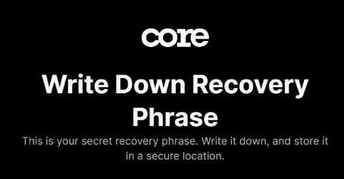Step 1 : First to download the chrome extention of core wallet

Step 2 : Then connect the wallet or set up your wallet manually then you will get a 12 -24 words which is the most important because by verifying it you access your wallet.

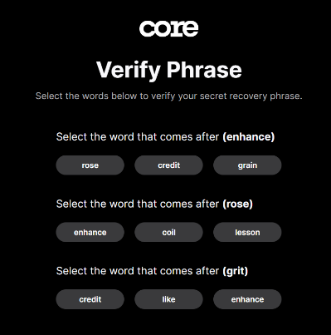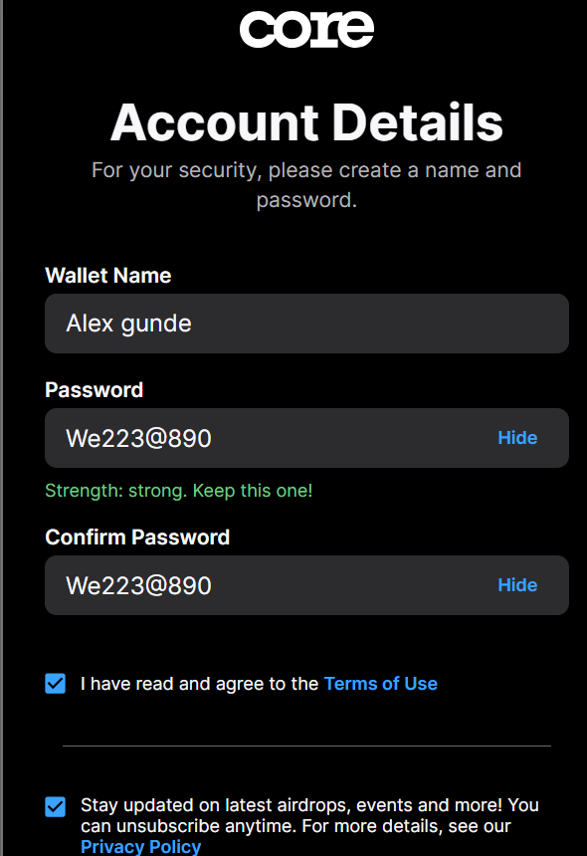Step 3: Verify your account using the phases and then set the wallet name , password and add email.

**Observation Table:**

* The recovery phase is the only way to connect to your wallet and it only appears ones .
* Ones you lost it you can recover it can not any way
* Private key should not be shared

